Tutorial 1 : Setting up and running a simple catchment model
The objective of this exercise is to set up a simple model for rainfall-runoff modelling on the Var catchment that has been introduced to you in the lecture.
This model will incorporate only the overland part of the water cycle. The river network will not be modelled, except for a very small part, next to the outlet. It is necessary to have this very small part of river network in the model in order to record the discharges generated by runoff in the downstream part of the catchment. The second tutorial incorporates most of the river network.

1. Starting MIKE SHE and creating a flow model
MIKE SHE is organised in such a way that it is possible to define a ‘working directory’ for each model. Such a ‘working directory’ contains all the data needed to build up a model.
- In the ‘Start’ menu, go to ‘Programs / DHI Software / MIKE SHE and click on the ‘Mike She’ icon. The general interface for all DHI software products is started (this interface is called ‘Mike Zero’)
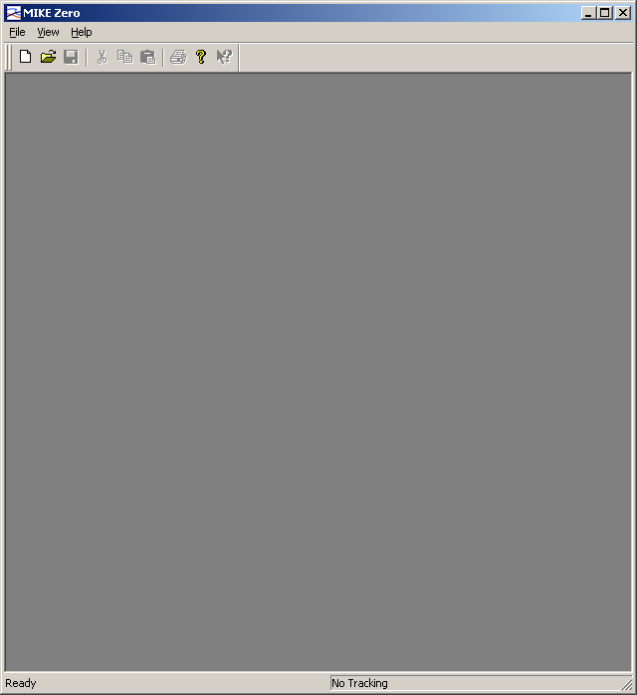
- This interface gives you the possibility to work on all the files handled by the DHI products. In these tutorials, you will restrict your activities to the Mike She and to Mike 11 files.
There are a number of steps to be followed follow, independently from the type of model you want to set up. These steps consist of defining the geometry, the topography and the precipitation distribution for the model.
- Create the setup file that will contain all the information related to your first Mike She model. To do so, the following operations must be performed:
3.a Click on the ‘File’ menu and select ‘New’. A window pops up, that gives you the possibility to create any type of DHI software file you like (see below for an example):
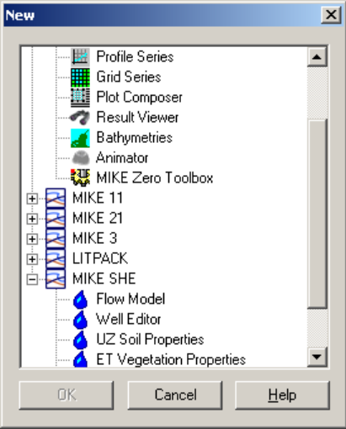
3.b The first step consists in creating a Mike She model. Go to the label ‘MIKE SHE’, expand it if it is not expanded yet, select ‘Flow model’ (see below) and click ‘OK’.
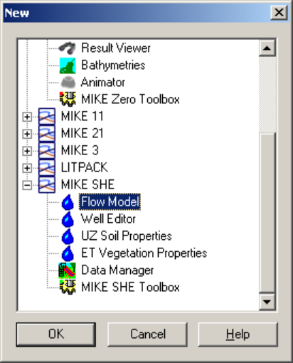
The following window appears:
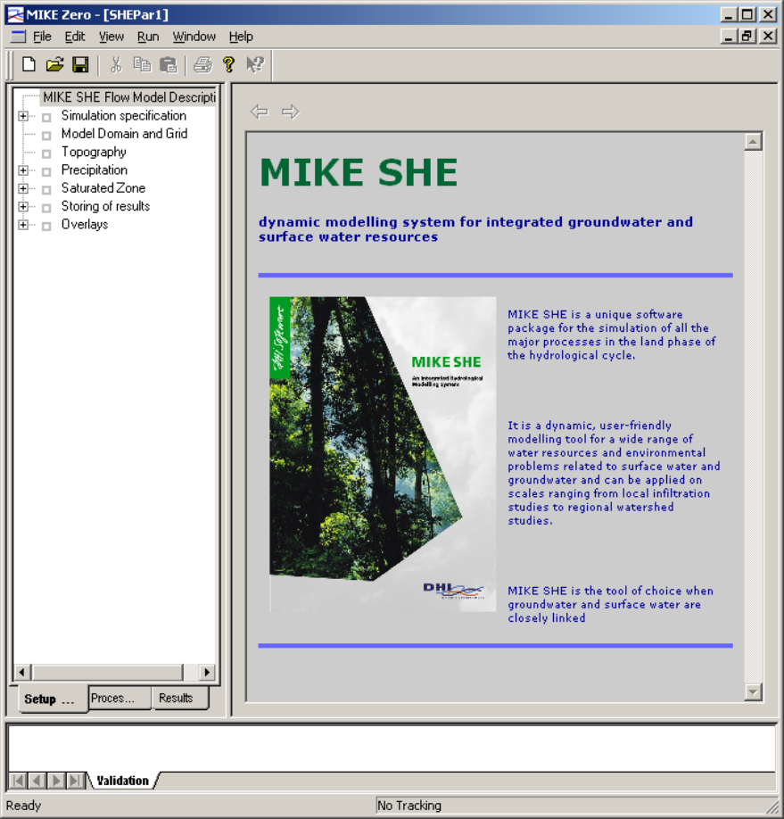
- Start with saving the (still empty) configuration file in the directory that will be used all the time during the present tutorials: ‘C:\She\Var’. Save the configuration file under the name ‘Model01.SHE’. The extension .SHE is compulsory !
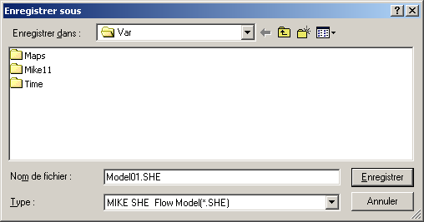
N.B. Do not forget to save your files from time to time.

2. Setting up a flow model: Compulsory steps
Mike She is a modular system (i.e. you may choose to include only the saturated, or unsaturated, or overland/channel flow modules, depending on the complexity of the mechanisms that you are willing to model). However, there are a number of operations to be performed independently from the component that you are willing to use. These operations are the following:
- You have to specify the topology of the model (i.e. the area covered by the model on which you are going to work),
- The topography (in the form of a DEM) must be specified in any case,
- The simulation parameters (simulation length and time step, etc.) must be specified.
- Expand the box ‘Simulation specification’. The interface should look as shown below.
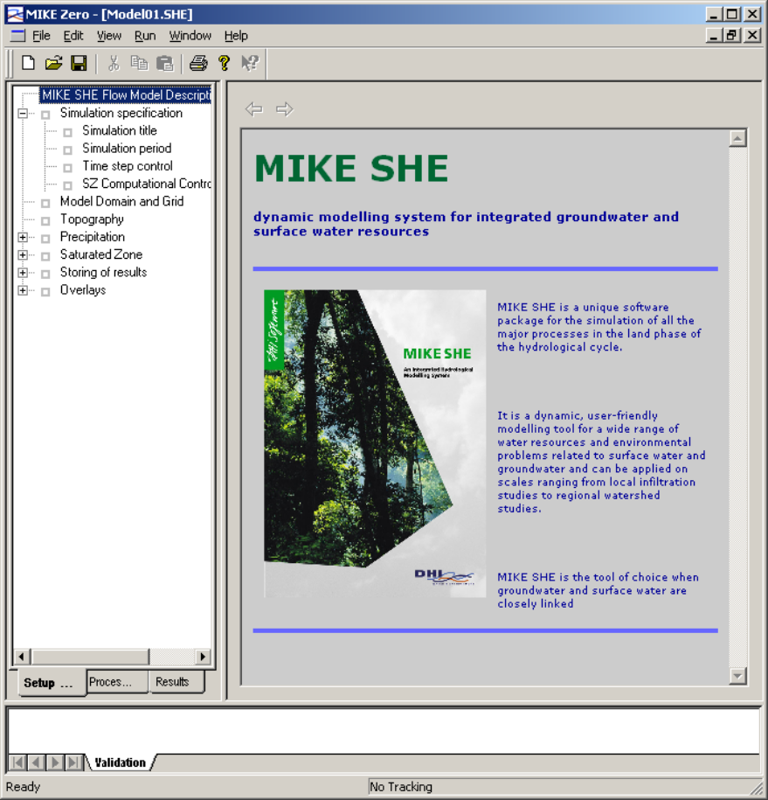
- Click on ‘Simulation specification’. This menu allows you to define the flow modules (i.e. the compartments of the hydrological cycle) to be included in the simulation. Make sure that the tick boxes ‘Water movement’ and ‘Overland (OL)’ are activated and that no other boxes is ticked. If it is the case, deactivate the related components.
N.B. Quite obviously, only the phenomena that have a significant influence on the behaviour of the catchment should be modelled and the other phenomena can be neglected. The modular structure of the Mike She system allows the components listed above to be included in the model depending on the modeller’s needs. For instance, it is possible to include only the overland/channel flow component if it is aimed to model flash floods triggered by intense rainfall events (because most of the water does not infiltrate and the predominant phenomenon is overland runoff). This is precisely what will be done in the present exercise, where you will work on catchment definition and specifications of a simple rainfall-runoff model. The other components will not be included. Still, it is necessary to close the hydrological cycle: one must specify the proportion of water that infiltrates or taken up by evapotranspiration. Since these phenomena are not calculated in the simple model your are going to build up, you have to specify your own guess for the evapotranspiration factor. This is done using a substitution (‘dummy’) component
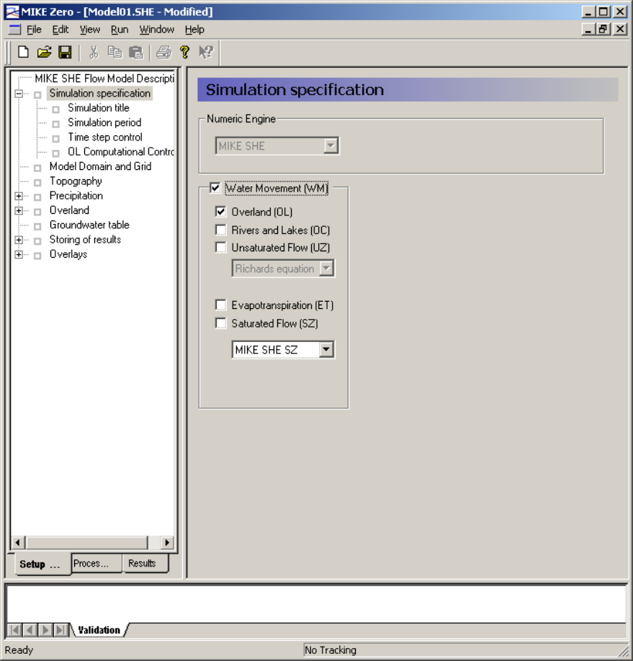
- Go to the sub-menu menu: ‘Simulation title’. There you may fill in any information that you might like to remember of later on when you come back to the model setup.
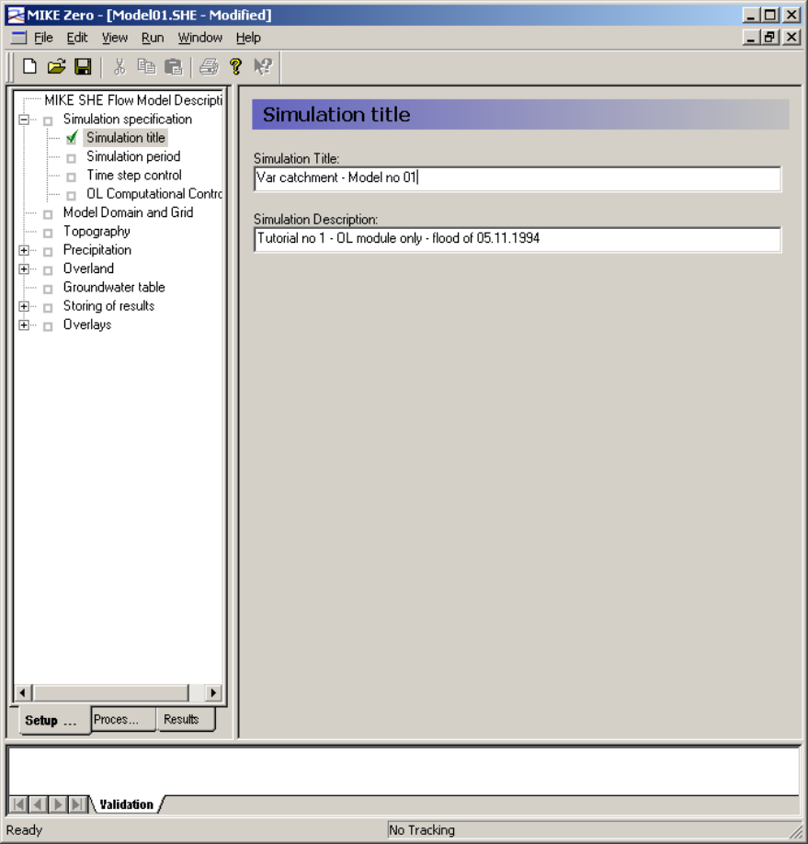
- Go to the sub-menu ‘Simulation period’. This menu is for you to specify the star and end date of the simulation. You can use either calendar mode or to increment the date using the small ‘up/down’ arrows next to the window box.
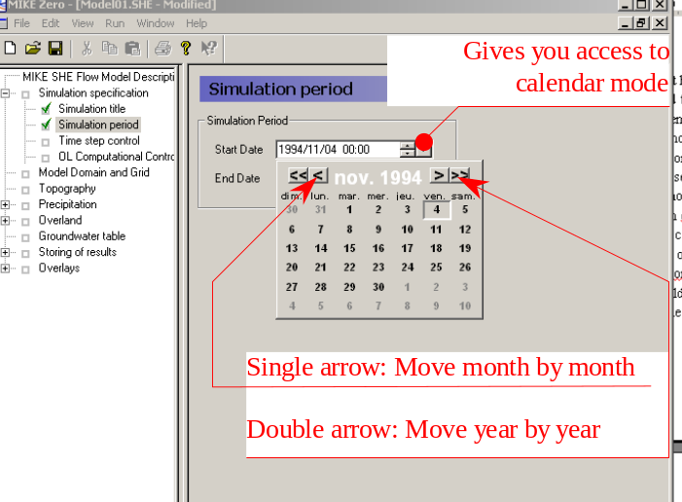
Set the dates as follows:
- Start date: 5 November 1994, 00hr00,
- End date 6 November 1994, 00hr00.
- Go to the sub-menu ‘Time step control’ and specify the following values:
- Initial time step: 6 minutes
- maximum allowed time step: 1 hour
- increment of time step (that is, the proportion by which you are willing to increase the time step if there is not too much rain falling): 0.05
- Max precipitation depth per time step (unit: mm): 20. The time step will be adjusted automatically (when necessary) in such a way that the amount of precipitation falling within one time step will not exceed this value.
- Precipitation threshold rate: 0.05 (unit: mm/hr): precipitation rate above which the reduction is applied (if necessary).
- Go to the Sub-menu labeled ‘OL Computational Control Parameters’. Set the following parameters:
- max iteration no: 20
- iteration stop criteria: 5×10^{–5} m
- water depth threshold: 10^{–4} m
- Menu ‘Model domain and grid’: this is where you have to specify the catchment area in the form of a map. When you select this menu, a red cross appears in the left-hand side window in order to remind you that no information has been provided yet and that it is compulsory.
- click on the triple dot button in order to select the grid file. The file selection menu appears (see below).
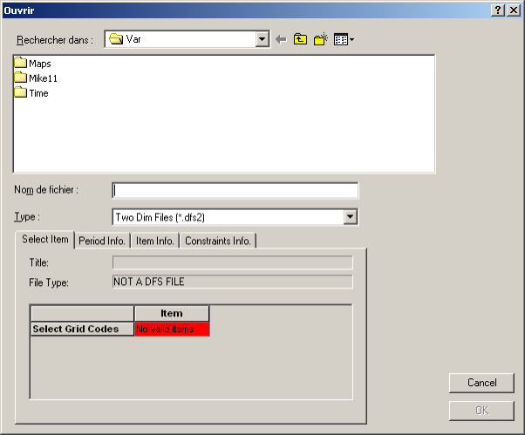
- go to the directory ‘Maps’ and double-click on the map ‘Grid.dfs2’. The map is loaded and the catchment shape is displayed in a the overview box:
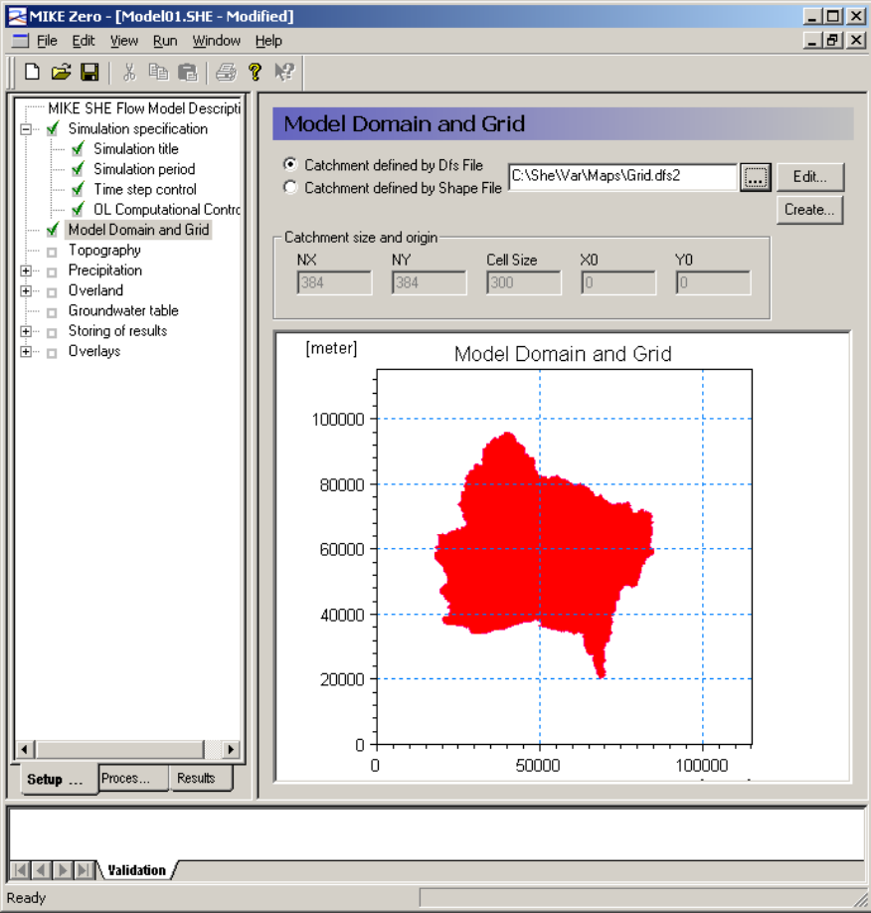
- Go to the menu ‘Topography’. The topography is stored in a file.
- In the window ‘Spatial distribution’, select the option ‘Grid file (.dfs2)’
- use the ‘triple-dotted button’ to select the topography data file ‘Topography.dfs2’ that is also stored in the ‘Maps’ directory. You are also given an overview of the topography in the window.
- Go to the menu ‘Precipitation’. Make sure that the option for snowmelt is not activated.
- Sub-menu ‘precipitation rate’
- Spatial distribution: select ‘Station-based’; Data type: select ‘Grid codes’ and load the precipitation code file: ‘Pstats.dfs2’ located in the folder ‘Maps’
- The number of precipitation stations is automatically determined by the software and the menu in the main interface expands into as many submenus as there are rainfall station codes. Each of them must be filled in with the time series corresponding to the station code.
- for each rainfall grid code: select the Temporal distribution option: ‘Time varying (.dfs0)’. The data file is called ‘prate.dfs0’ ad is located in the folder ‘Time’. When you load the file, select Item 1 for station 1, item 2 for station 2, etc. The screen dump below was made for the 3rd station.
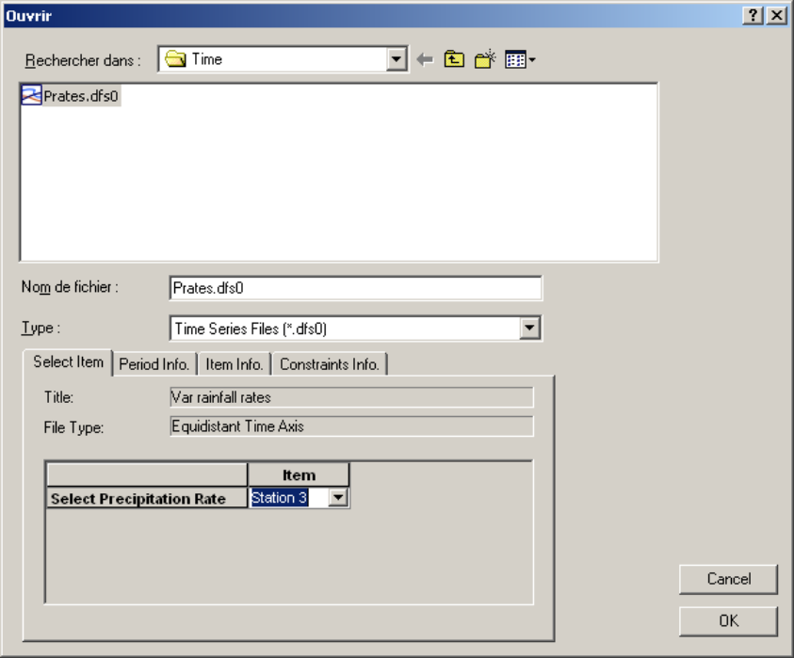
- Last submenu: ‘Net rainfall fraction’. Choose ‘uniform’ and assign a value of 0.9.
- In the end, all menus and submenus dealing with the precipitation rate distribution should be ticked with a green mark, as shown below.
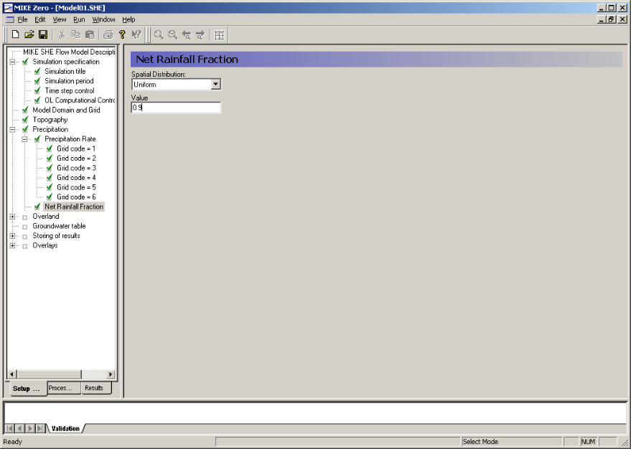

3. Component-dependent specification: Overland (OL) flow module
- Unfold the menu ‘Overland’. Several submenus appear.
- Menu ‘Overland’, make sure that ‘separated overland flow areas’ is not activated, that the option ‘Full contact in entire catchment’ is activated.
- submenu ‘Manning number’: assign a uniform value of 20 (this is in reality the Strickler friction coefficient !)
- Detention storage: assign a uniform value of 0
- Initial water depth: uniformly 0
- Menu ‘Groundwater table’ (not used in the present simulation): uniformly 0.

4. Specification of result storage
The last thing that you need to do before compiling and running the model is to specify the nature and frequency of the computational results to be stored.
- Unfold the menu ‘Storing of results’. Activate ‘Storing of water balance’ and deactivate ‘Storing of AD input data’ if it is already activated.
- Submenu ‘Detailed time series output’: this allows you to store the computed flwo variables at each timestep at specific points.
- click on the dotteed rectangle with a yellow spark in order to add a storage point. A new line appears in the window
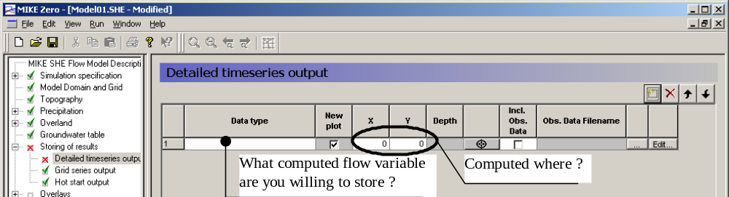
- Go and click the leftmost blank field: you are given choice between the variables that can be stored
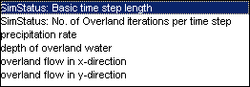
- Select ‘depth of overland water’
- then go to the blank fields for x and y. Entrer 68120 for x and 24520 for y.
- The interface should look as shown below:

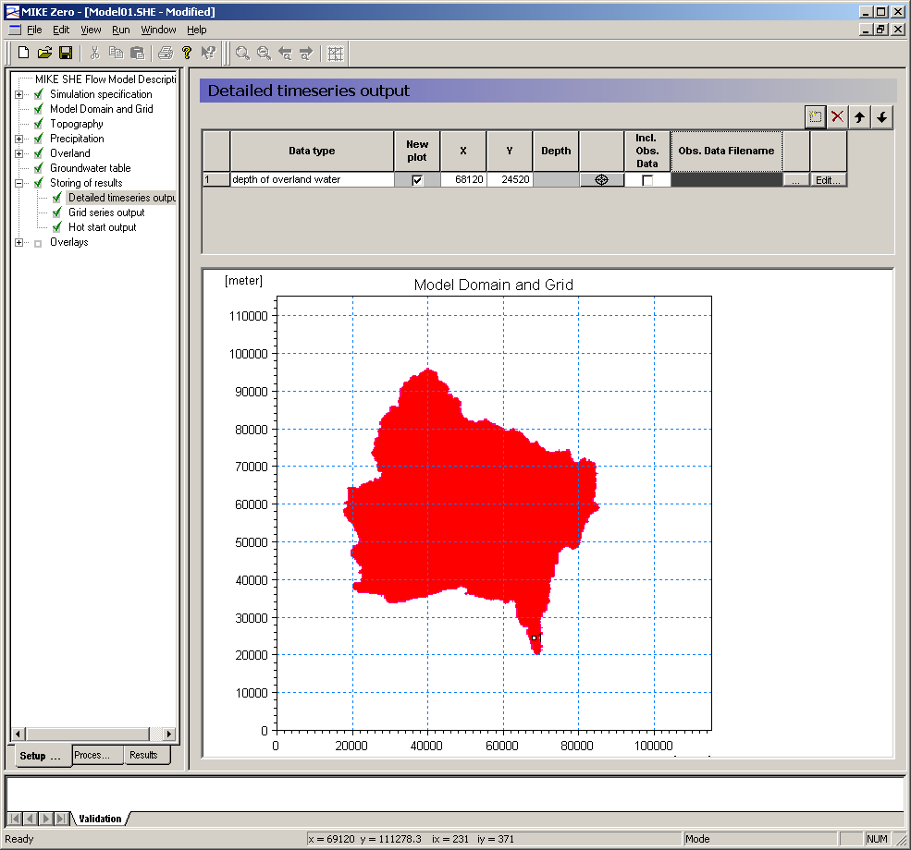
- Repeat the operation for another 2 points: store the water depth at (x = 68420, y=24520) and (x=68720, y=24520).
- Submenu ‘Grid series output’: since you decided to carry out a water balance, all available simulation variables have to be stored. Make sure that the storing interval is 1 hour.
- Submenu ‘Hotstart output’: you are not going to make any hotstart, so a storage interval of 24 hours is sufficient.

5. Compiling and running the model
- In the bar menu ‘Run’, select ‘Preprocessing’ in order to compile the model data. The following window appears and tells you that the preprocessing was completed successfully.
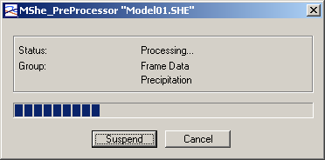
- In the bar menu ‘Run’, select ‘Start simulation’. The status bar indicates the simulation progress.
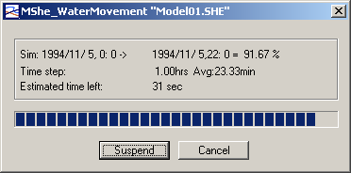

6. Visualising and exporting simulation results
Once the simulation is completed, you are given the possibility to visualise the computed flow variables in the form of maps (at a given time) or time series (at a given point).
- Activate the ‘Result window’ by clicking on the corresponding bookmar at the bottom of the left-hand side window. Expand the tree under ‘Results of simulation’ by clicking the square box marked with a ‘+’
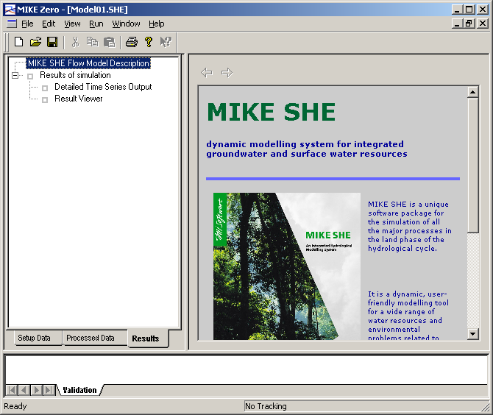
- Go to ‘Result viewer’ (since you did not request any detailed time series output for this simulation). The computed variables stored in the result files are displayed in the right-hand side window.
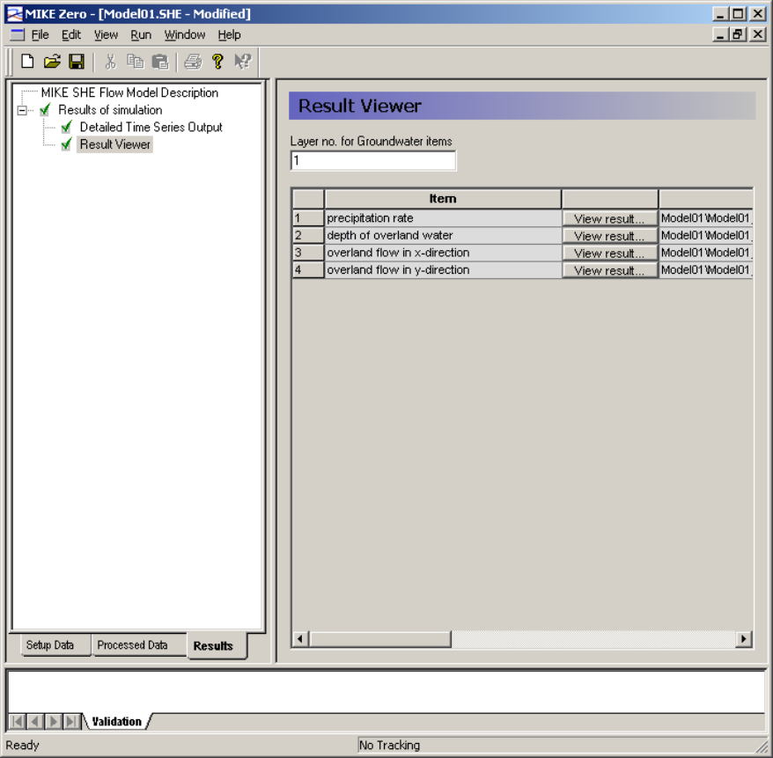

5.1 Visualising/exporting maps
The simulation results are stored in a time-varying map file (extension .dfs2). There is one file for each simulation variable. The name and location of the files are specified in the rightmost column of the right-hand side window (use the scroll bar if necessary to see the full name).
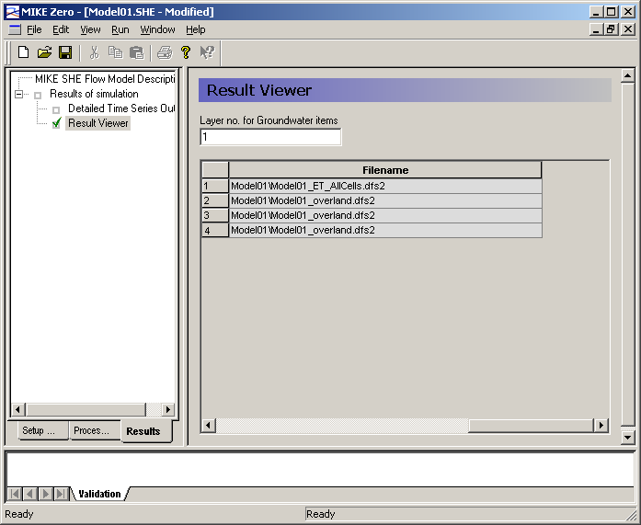
- These map files can be opened using the same map editor as for input data:
- Click on the pop-up menu File/open
- File type: select ‘2-D grid files’
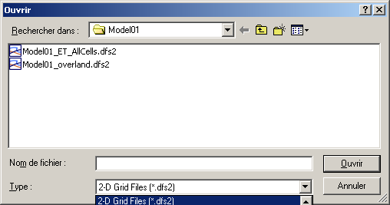
- Go to the folder ‘Model01’. This folder is a sub-folder of the folder ‘Var’ in which you started the SHE.
- Select the file that you want to open. To have a look at the computed water depths, select the file Model01_overland.dfs2. The map editor is activated automatically.
- The main interface of the map editor is displayed
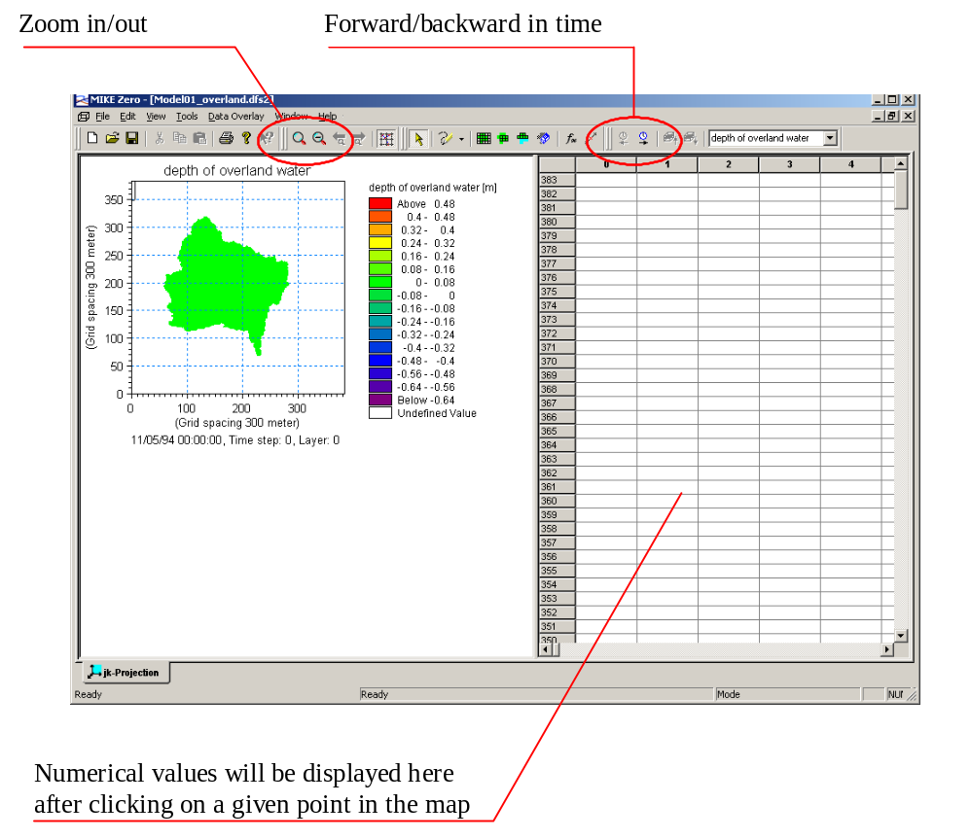
- The (+) and (-) magnifying glass icons are used to zoom in and out respectively,
- The blue clock-shaped icons allow you to go forward or backward in time when the map is a time-varying one,
- if you click on a point of the map in the left-hand side window, the numerical values around this point will be displayed in the right-hand side window that looks like an Excel calculation sheet. Moreover, the shape of the region covered by the right-hand side window will be displayed on the map of the left-hand side (see below). The numerical values and the colour map are updated automatically as you go forward or backward in time using the clock-shaped icons.
- You may copy-paste these values into Excel using the usual commands.
